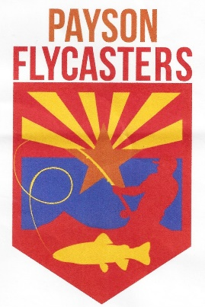
Payson Flycasters
& TU Chapter 530 Newsletter

Issue 49 www.paysonflycasters.org www.gilatrout.org November 21, 2022

Next Meeting Date | time 11/26/2022 12:00 AM Location Tiny’s Restaurant Payson AZ
November 26 Meeting Program: This month’s guest speaker is Bryce Sisson, manager of the Tonto Fish Hatchery. Bryce will discuss recent fish culture improvements and production changes at the hatchery with information about the four species of trout (Apache, tiger, brook, rainbow) raised there.
Our meetings are held the last Saturday of the month at Tiny's Restaurant in Payson at 9am. Folks generally arrive earlier to talk fishing and have breakfast or coffee. We would love to have you join us.
Remember—Holiday Party is December 17 at the Casino—Get Your Tickets at the Meeting!!!
Social hour 5:00 to 6:00, dinner 6:00 in the Fireside room at Mazatzal Casino. Everyone needs to bring white elephant gift. $30.00 per person. Menu: garden green salad, either herb rubbed prime rib or breast of chicken, twice baked potato, vegetable medley, rolls and butter and assorted cheesecakes. There will be a floating cocktail waitress. Tickets available from Dorothy Howell. Tickets MUST be purchased by Dec. 12th, please.

Here's the Newest Logo and Pin (sample hats and shirts available at the meeting) Focus is on TU Chapter 530 Which Is Where We Are Encouraging People to Go to Buy Things.
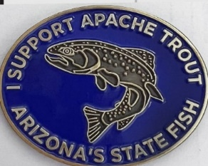
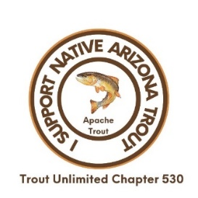
On the left is the new logo using the fine art version of an Apache Trout and the switch to “I Support Native Arizona Trout” with the more of a Trout Unlimited Chapter 530 focus. The new pin is now in stock and is on the right. It is the same size as the first one and will hopefully appeal to other clubs as did the first one for a wider group of donators. It is on the website, asking for a $25 donation.

December 2—TU and Flycasters Display at Hometown Heroes Community Event

Bring your friends to celebrate not only our own club member volunteers but all those from the Senior Center, Food Banks, Hospital, Christian Clinic, and more. Grab a cookie, visit the other tables and learn about other volunteer organizations. The event is at the Methodist Church from 3-5. It is located at 414 Easy Street behind Ace Hardware. Our team will be there too with information about what we do.

Tom Herman continues to look for gift cards from local merchants for our monthly raffle. Ask the next time you get a pizza or eat out, or shop. Can’t hurt. Or buy one and donate it please. Bring it to the meeting.

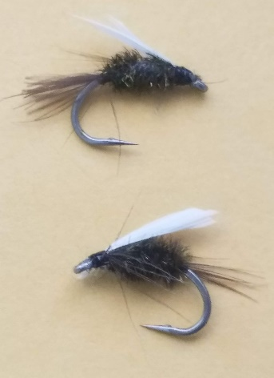
What is your favorite fly?
Article and Photos by Jim Strogen

My uncle taught me to fly fish when I was about ten years old. I only saw him use two flies in all the years we fished together, and his absolute favorite was the wet fly coachman, which looks similar to a prince nymph. He explained the advantages of that fly, and it made total sense to me. To a fish, it looks buggy with the peacock herl body, the soft hackle beard for legs and a soft hackle tail. The real key though is the white wings that the fly fisher can track as it is drifted and worked downstream into likely spots. That was pretty much the only fly I used for probably the next ten years, and I caught a lot of fish on it.
While I still know that I could continue to do very well with just the coachman, I have broadened my fly selection a bit since then. Like many of you, I have a bunch of fly boxes. I organize them for different fishing purposes or destinations. I have a Lees Ferry box, an Alaska box, a San Juan box, a dry fly box, and an all-purpose box with probably close to 300 flies in it.
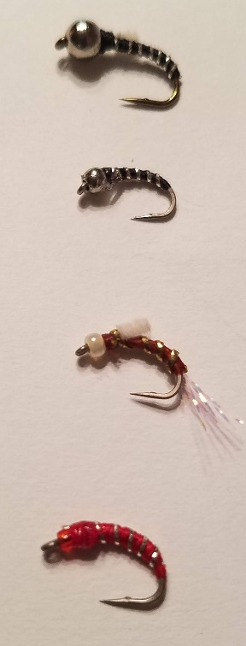
But when I fish these days, I mostly only carry two small fly boxes, and in reality, I rarely change the two flies that are on my fly rod. I should clarify that a bit, as I actually have two fly rods set up in my car. One is rigged with two dry flies and one is set up with two wet flies. Almost always I fish the wet fly rig. I use it at Green Valley Lake, the East Verde, and Tonto Creek. The other rod I use more often on the Upper East Verde, Upper Christopher, Upper Canyon, and Horton.
One of the interesting aspects of fly fishing that I really appreciate is that fly fishers are very willing to share what flies are working for them. I have had several conversations on a stream that have ended up with either receiving or giving a fly that was working that day.
All of this got me thinking about which flies I use most often. As most of you know, I am primarily a wet fly fisher, so the fly selection is heavy in that category, and the dries that I typically use are buoyant enough to hold up a wet fly trailer or small bead-head.
My top flies include: prince nymph or wet fly coachman, hare’s ear, pheasant tail, zebra midge, wooly bugger, leech, elk hair caddis, humpy, stimulator, and a beetle. If you looked at my two little fly boxes, they would have a variety of sizes and colors of these flies both weighted and unweighted. And If you looked at my fly rod, you would usually see two flies in particular that are there most of the time.
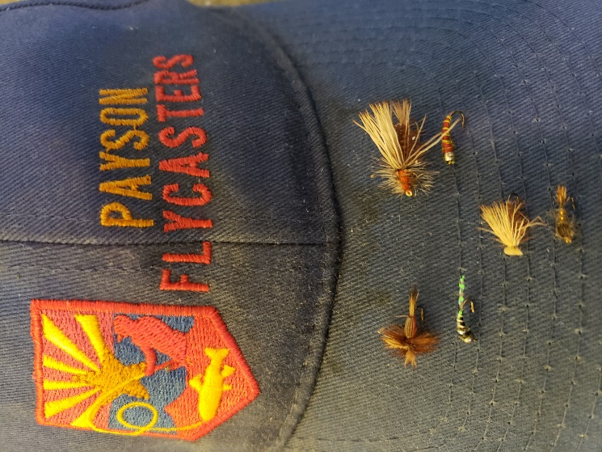
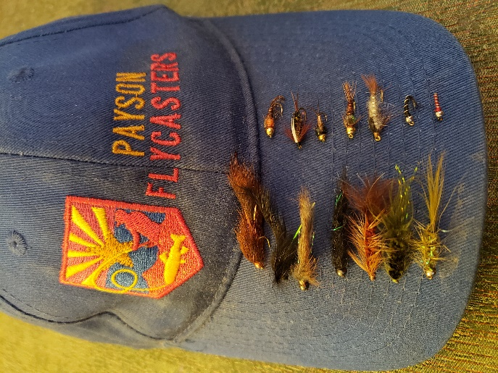
What would make your top ten flies? What about your top five? What fly would be your all-time go-to fly?

I will plan on asking folks at our next meeting to list their top 10 flies, and ask you if you only had one fly to fish with, what would it be? I will tally and share the results with you.

Some of Jim’s Favs. See them up close at a future meeting.

