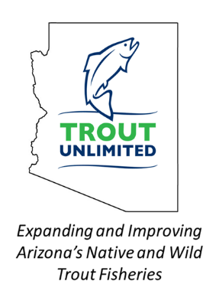
Payson Flycasters
& TU Chapter 530 Newsletter

Issue 38 www.paysonflycasters.org www.gilatrout.org November 15, 2021

November meeting is November 20 a week earlier due to Thanksgiving.
We are happy to be getting back to normal with our meetings. Tiny's Restaurant is now open! We will have our November meeting at 9am on November 20th in our normal meeting room at Tiny's. As in past years, many of us will be arriving about 8am to talk fishing and enjoy some coffee and breakfast before the meeting. We hope that you will be able to join us. This is a week ahead of our normal meeting date of the last Saturday of the month as we did not want to compete with family events over the Thanksgiving weekend.

In our recent survey of members, the top vote for topics was for a presentation on Rim Country streams. Jim Strogen will be sharing information on the various Rim Country streams that many of us fish and will include some tips on how he fishes these small streams. Fall is a fun time of year to get out on these streams. The water has cooled, and the foliage has opened up some of the brushier sections of the creeks to allow for a bit easier access. While stocking has ended, there are hold-over fish that are fun to catch, and several of these streams also have wild populations that are great to target in the fall. Please join us for the presentation at 9 am on November 20th at Tiny's Restaurant.

Got Your Holiday Party Ticket Yet? See page 3 for details--December 3 at Casino.

GVL Clean-up Day Report: November 5

Members collected trash from around the lakes and from the water. Then fished. Here’s Bill Davis, TU VP and Ric Hinkie on the water side of the pickup. Gary Altman, Dorothy Howell, Jim Clayton, Larry Hess, Deems Davis, Jim Strogen, Rich Butout, Robert Walsh, Bob Eckert and others were all helping clean up the lake. Amazing what junk ends up in and around the lake. We were carefully supervised by a native. See below.

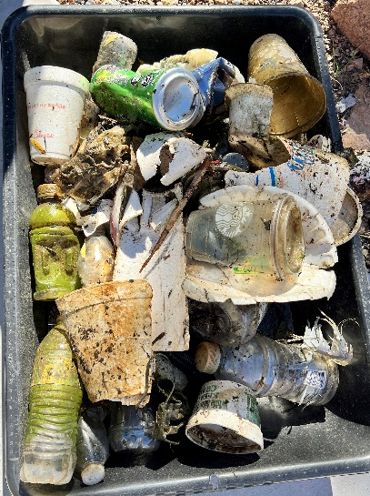
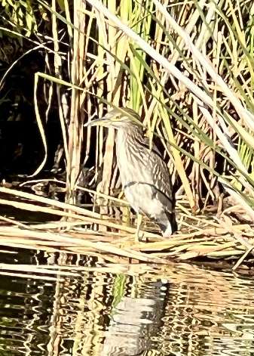
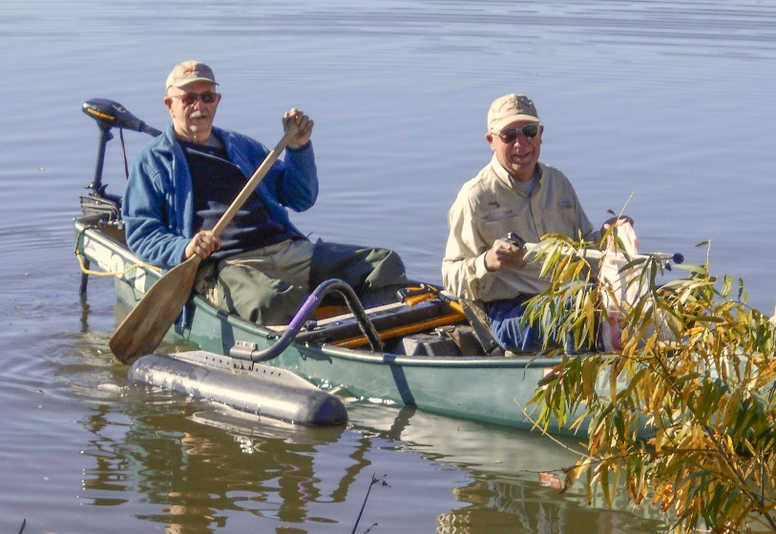

New Mugs Are Available Featuring our Logos and the MonaGila
Just $15 dollars for members at the meetings.

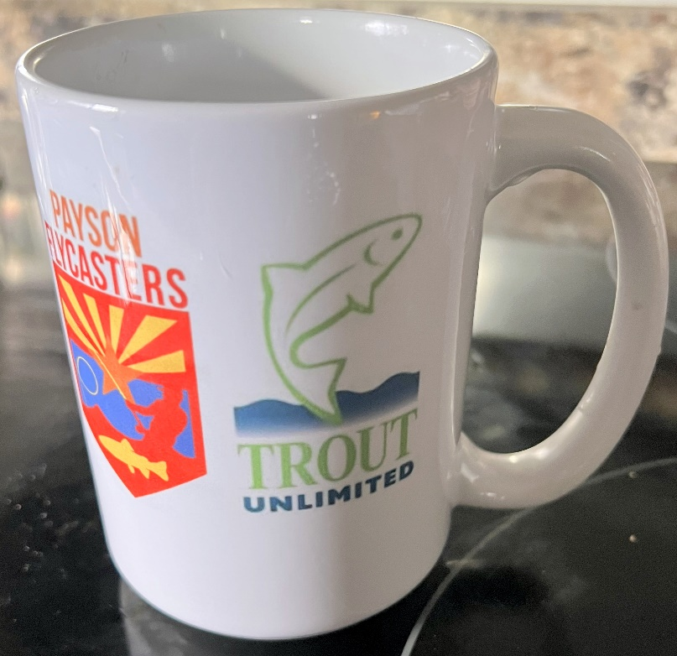
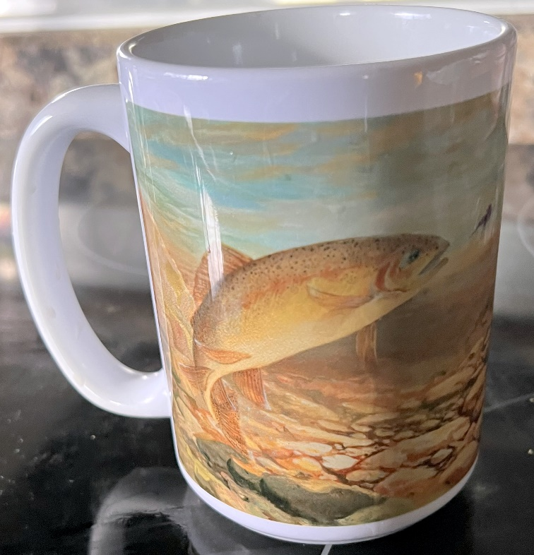

Two Rods
Jim Strogen
I broke the tip of my Sage rod last fall at Woods Canyon Lake. I was being really careful. I propped it up against the wall of the bathroom positive that it would not fall, and just as the door closed, the wind kicked up and the nine-foot rod was now 8’9”.
With Covid in full swing, and a surge of new fly fishers wanting to get outdoors, to get my favorite rod replaced by Sage would take three months or more. Fortunately, we have a great rod builder and repairer in town, AZGFD Commissioner Jim Goughnour. While he couldn’t get a new tip section from Sage any quicker than I could, he offered to put a temporary tip on the shortened rod to see if I was comfortable with the action. It still performed my roll casts very well and kept my accuracy with my overhead casts. He made the fix permanent, and it works as good as new.
I was feeling a bit sorry for myself as I sorted through this dilemma and had begun to leaf through the Sage rods online. I decided that with my birthday coming up that a new Sage
Foundation would be a good idea. So now I have two great rods. Two rods are not new to many float tubers, but it adds a bit of planning and hassle to a dedicated stream fisher and lakeshore angler.
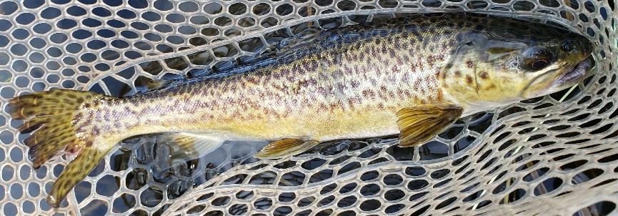
As many of you know, I am an infrequent dry fly fisher. I decided that a way to help me be more willing to fish dries more often was to dedicate a rod to it, and have it rigged up next to my wet fly rod in my car.

Woods Canyon Tiger
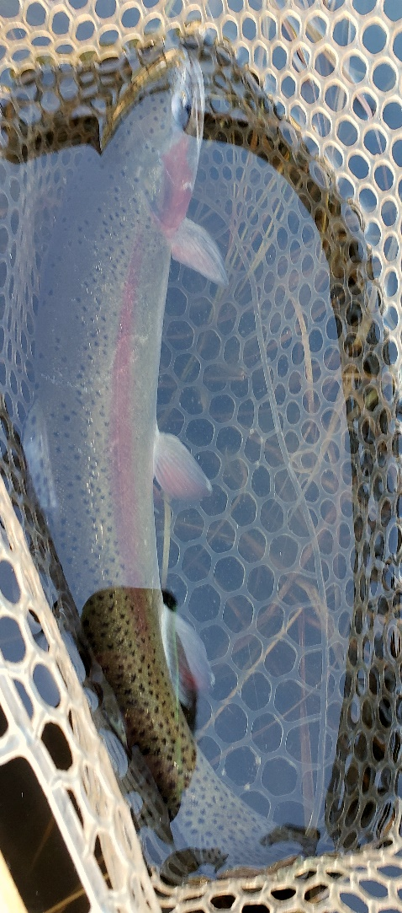
When the situation seems warranted, I now bring both rods to the water. I have done this at Green Valley Lake, Christopher Creek, Woods Canyon Lake and Willow Springs Lake. It has really been helpful at Woods Canyon and Willow Springs where I don’t move much more than a few hundred yards during a trip, but like the option of having very different fly rigs already set up for immediate use as the situation demands.
When the wind kicks up on the Rim Lakes I can shift to my woolly bugger/ leech rig and strip them four or five feet under the choppy surface. When the wind drops and the fish start rising again, I am all set up to through dries or my dry/midge rig.
When I fish Woods Canyon and Willow Springs Lakes, I range between wooly buggers and leeches, to bead-heads and zebra midges under an indicator, to stimulators and zebra midges or smaller dries with an emerger trailer. Having two rods has allowed me to quickly shift to a new attack plan as the fish or conditions dictate.

I also think it makes sense for Silver Creek. With big fish and tight conditions, the threat of breaking a rod is always a possibility on Silver Creek. Why not carry two rods and rig them differently to try on a stretch of stream that you just know has plenty of big trout that might be looking for a different offering than what you just tossed at them?
I am looking forward to another two-rod opportunity this spring. I still love catching bluegills and crappies just as much as I did when I learned to catch them on a fly as a kid. So. I will have a rod set up for bluegills and crappies, but as the big grass carp in Green Valley Lake
cruise the shoreline, I will have a heavier rod rigged up to give them a go. Are there situations that two rods might Woods Canyon Rainbow make sense for you?

Got Your Holiday Party Ticket Yet?

Now’s the time. Buy in person at the November meeting or better yet use your credit card safely at www.paysonflycasters.org. Easy peasy.
Or contact Dorothy Howell Dandort@msn.com
Great food, great company, great gifts, and prizes. Even a raffle. Be sure and bring a White Elephant gift all wrapped up. Could be silly, could be very cool, could be anything. You’ll have a chance to bring something neat home for yourself.

Fall Fish Catching Tip from Tom Herman Lots of have been catching Rainbows and Tiger Trout at Willow Springs and Woods Canyon for the last couple of weeks. It seems the trout are fattening up for when the lakes freeze over, and are very close to shore, and eating hoppers, foam terrestrials (sz12 foam beetles), large streamers and midges. Wait until the sun is out since it’s warmed up and the fish seem to be near the surface all day long. Since its windy you can get off some amazing casts (ask Bob Walsh). Some biggies are being caught. Good Fishing. Also plan on joining the San Juan trip planned for March 21-27. Ask Tom.

Project Healing Waters Day—Good Fishing, Good Company, Good Chili

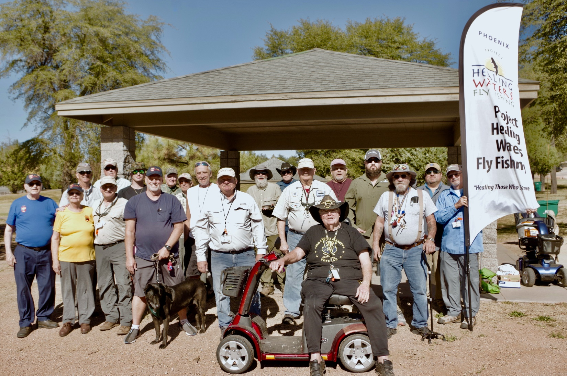

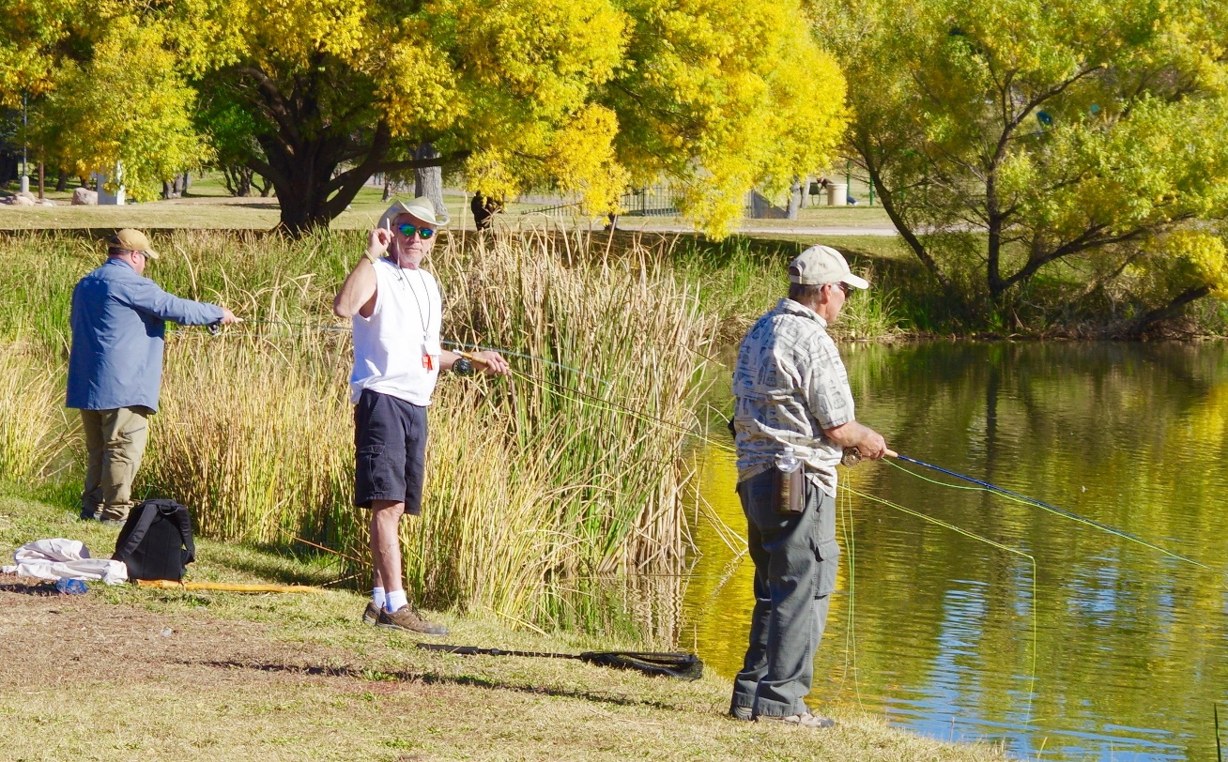
The gorgeous Payson Fall weather cooperated and so did the fish.

Members got to host these veterans for coffee and rolls, fishing and then Dorothy’s Chili.

Photos by Bob McMenemy

